# **CRM Application for Jewel Management**

**College Name:** Vidyasagar College Of Arts & Science

**College Code:** bru30

**TEAM ID:** NM2025TMID26864

**TEAM MEMBERS:**

**Team Leader Name:** YUVARAJ K

**Email :** yuvarajk231048@gmail.com

**Team Member :** Premkumar S

**Email :** Premkumar23221041@gmail.com

**Team Member :** Rajamanickam. C

**Email :** rajamanickamc231044@gmail.com

**Team Member :** Radha R

**Email :** radhar1043@gmail.com

**Team Member :** Sridhar A

**Email :**  sridhar231045@gmail.com

# 1.INTRODUCTION

**1.1 Project Overview**

Jewel CRM in Salesforce is a customized customer relationship management system built on Salesforce to manage jewellery business operations like customer profiles, sales, inventory, repairs, custom orders, and marketing campaigns with automation, reports, and integrations.

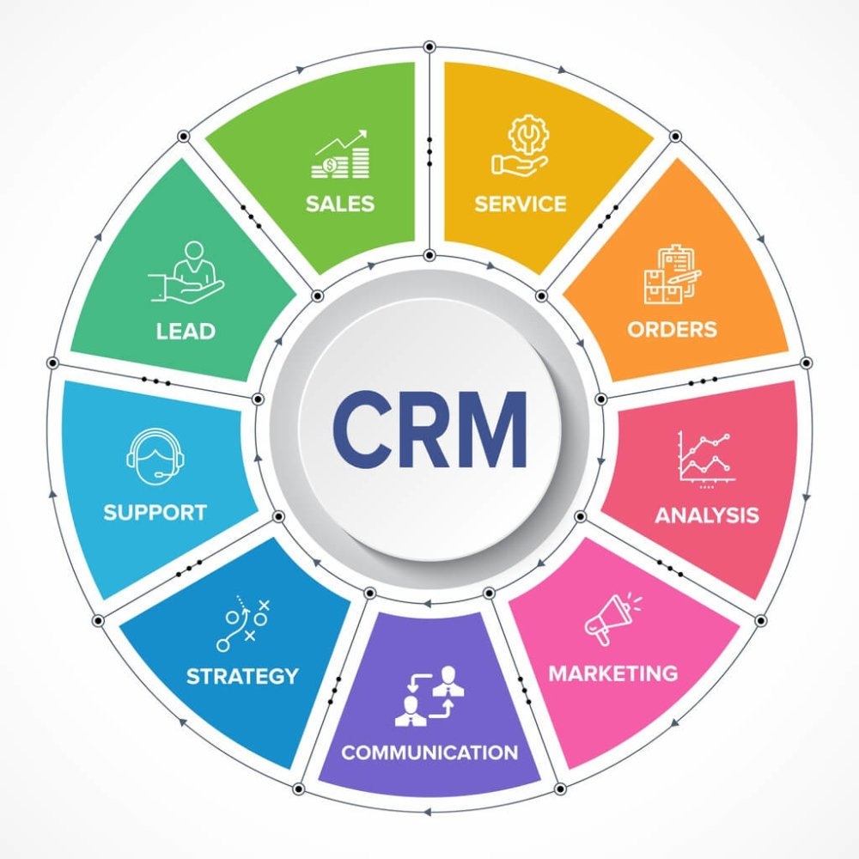

**Objectives:**

The main objective of building the Jewel CRM is to streamline business processes and improve customer relationship management. It aims to provide better visibility into customer preferences, simplify sales and billing, maintain accurate inventory records, and track repair or custom orders with ease. By integrating these processes, the CRM delivers business value through higher operational efficiency, reduced manual errors, stronger customer loyalty, and improved decision-making with real-time data and reports.

# **DEVELOPMENT PHASE**

## 

## **Creating Developer Account:**

**By using this URL -** [**https://www.salesforce.com/form/developer-signup/?d=pb**](https://www.salesforce.com/form/developer-signup/?d=pb)

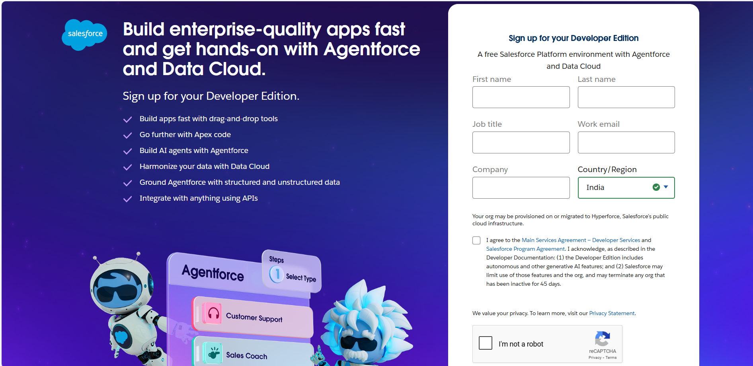

* 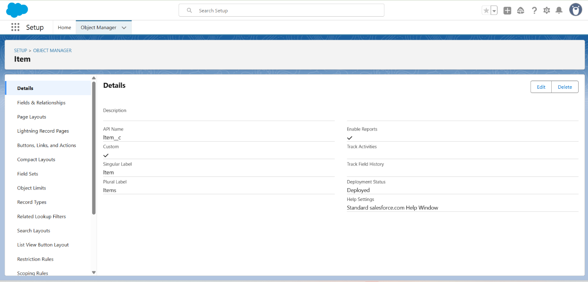**Creating Object : Customer, Item, Customer Order, Price, Billing**
* **Creating a Custom Tab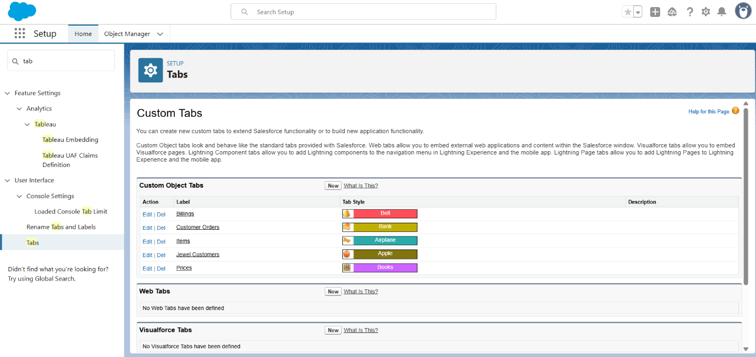 :-**
* **Create a Lightning App**

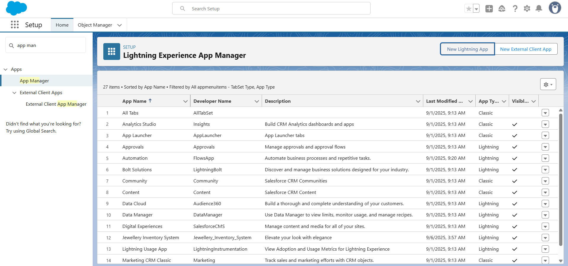

* **Creating Lookup Relationship**

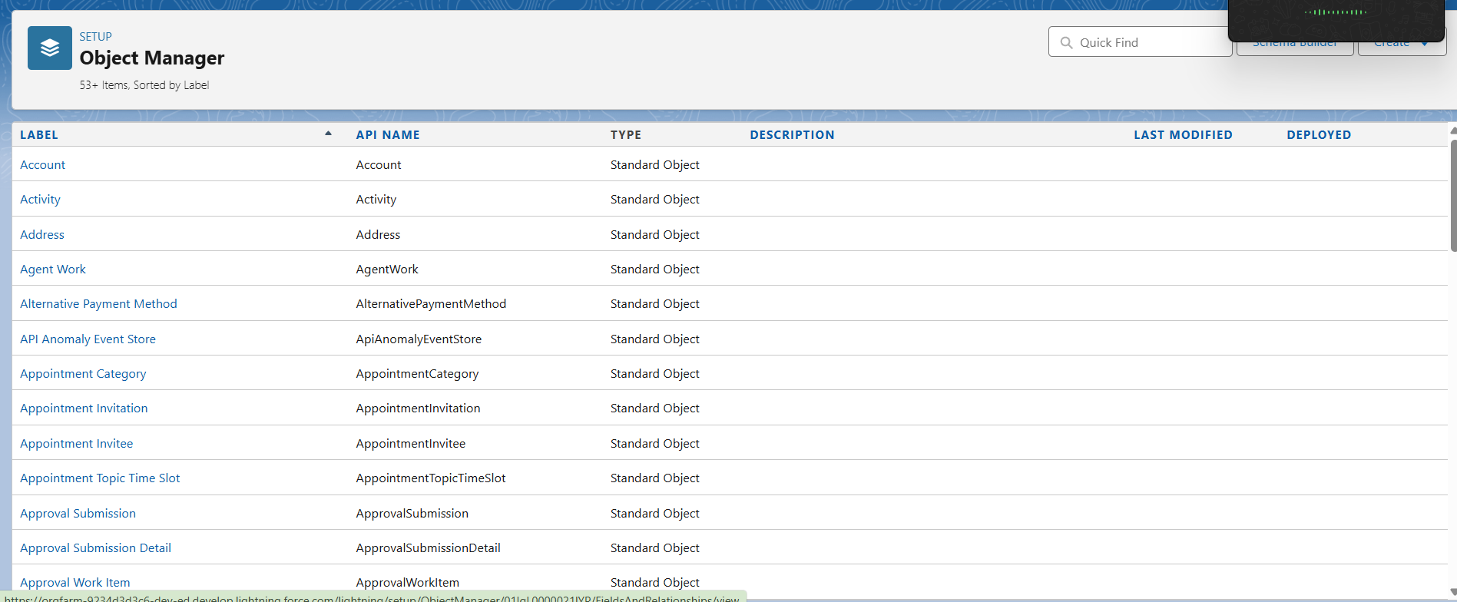

* **Creating a Master-Detail Relationship**

* **Creating Text Field in Jewel Customer Object**

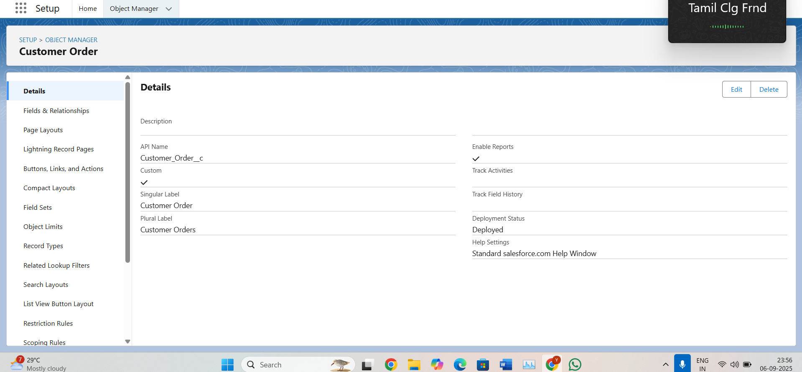

* **Creating the Phone field in object Jewel Customer**

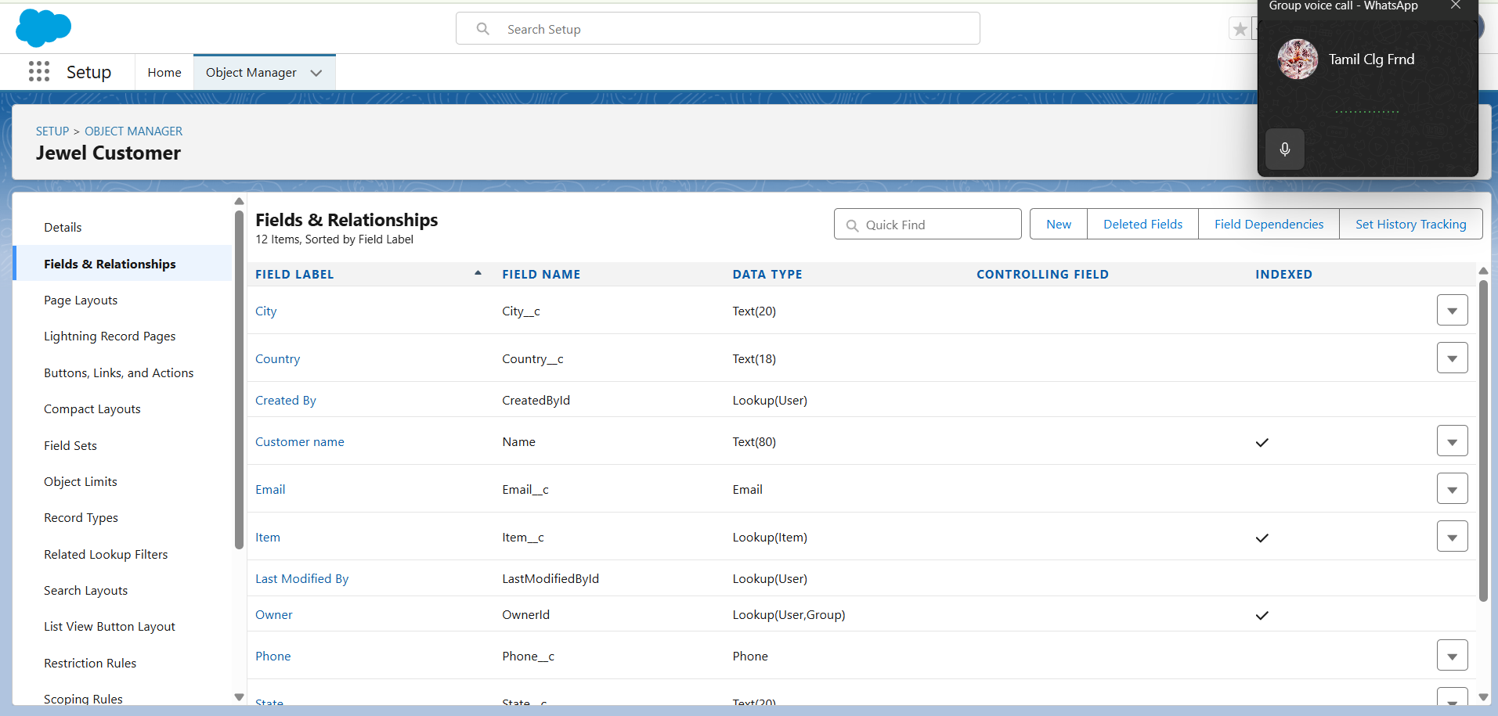

* **Creating the Email field in object Jewel Customer**

* **Creating the number field in Item object**

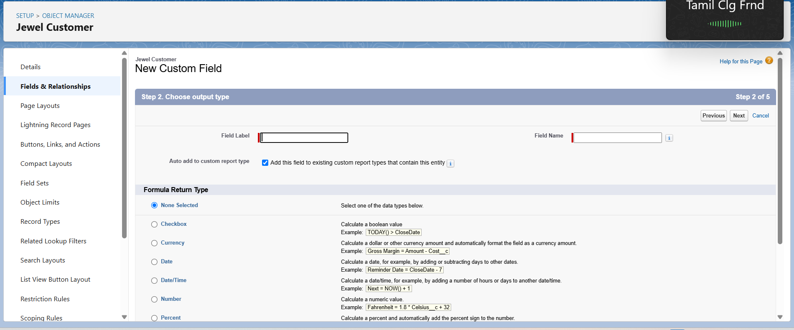

* **Creating Remaining Fields in Objects**

* **Schema Builder**

* 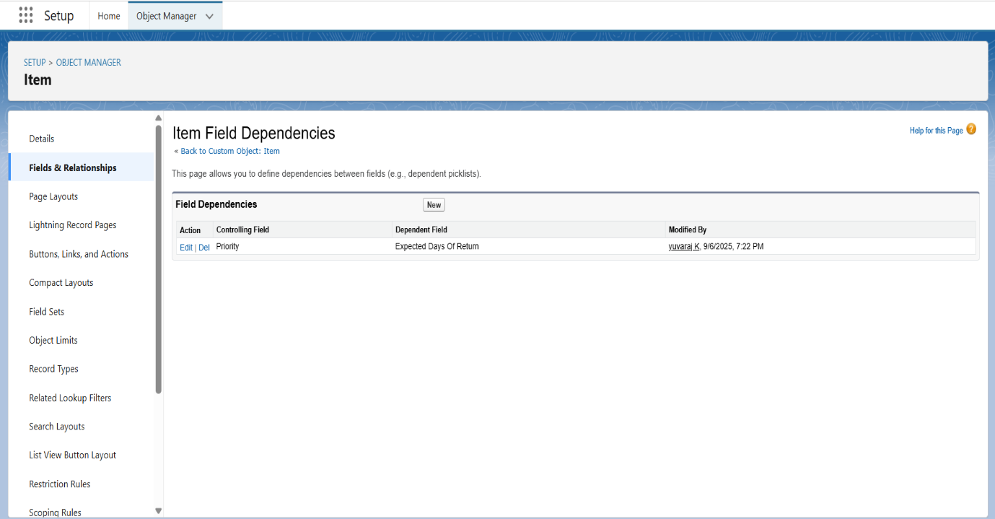 **Creating the Field Dependencies**

### **Creating the validation rule**

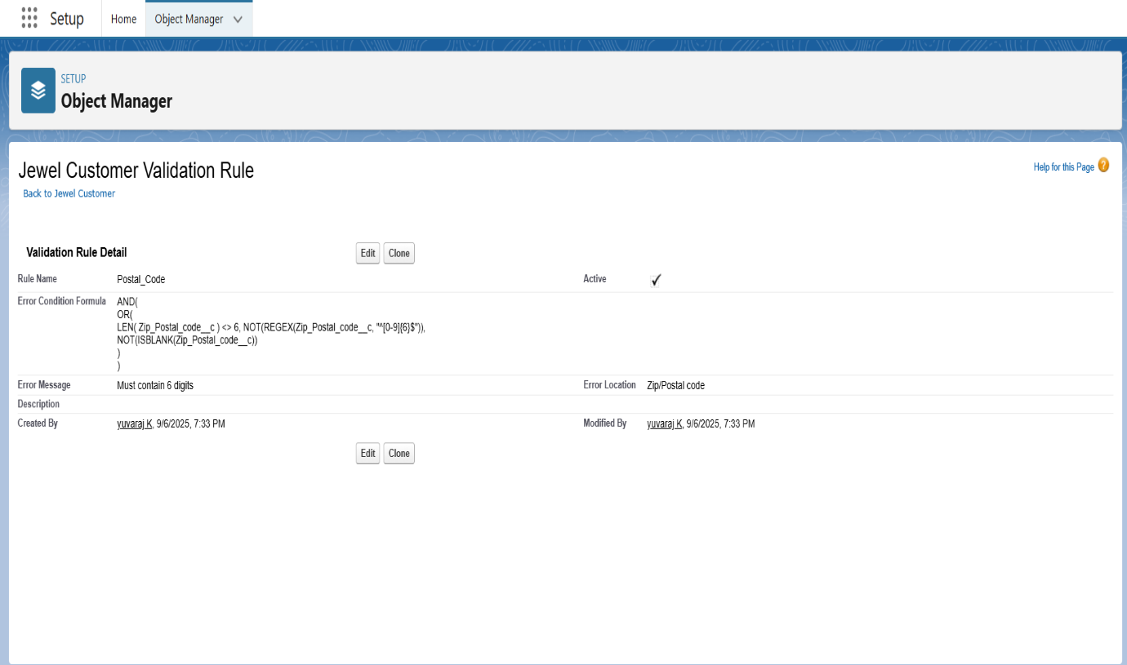

* **Creating Gold Smith Profile**

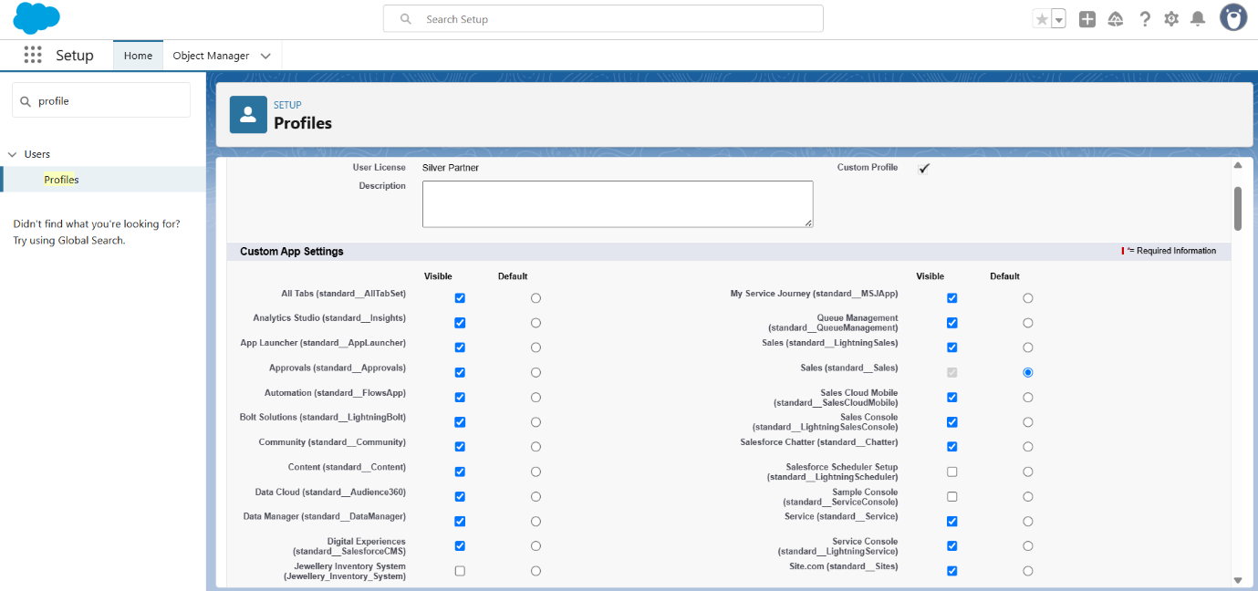

* **Create Worker Profile**

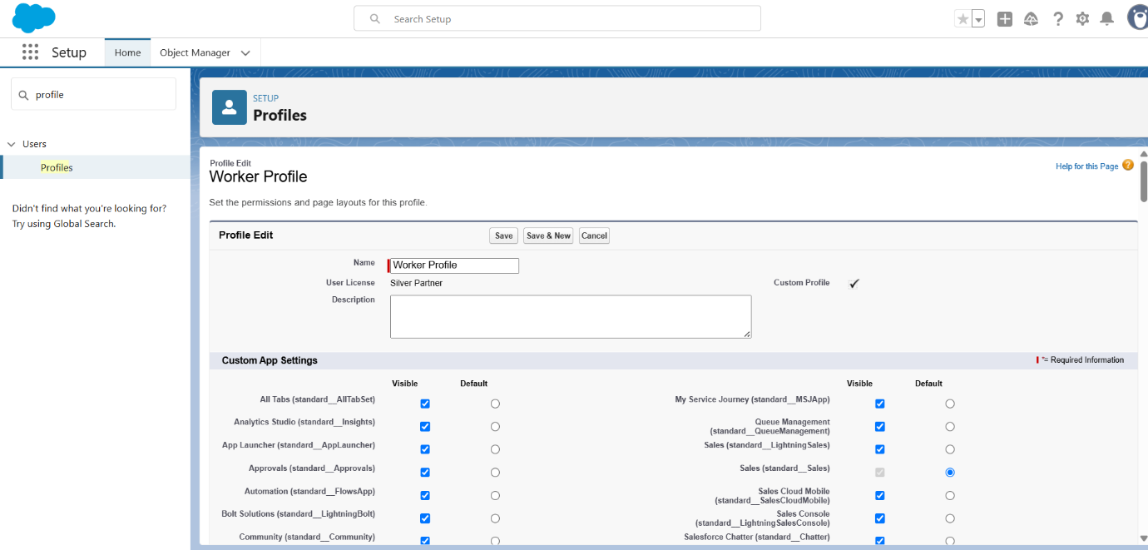

* **Creating Gold Smith Role**

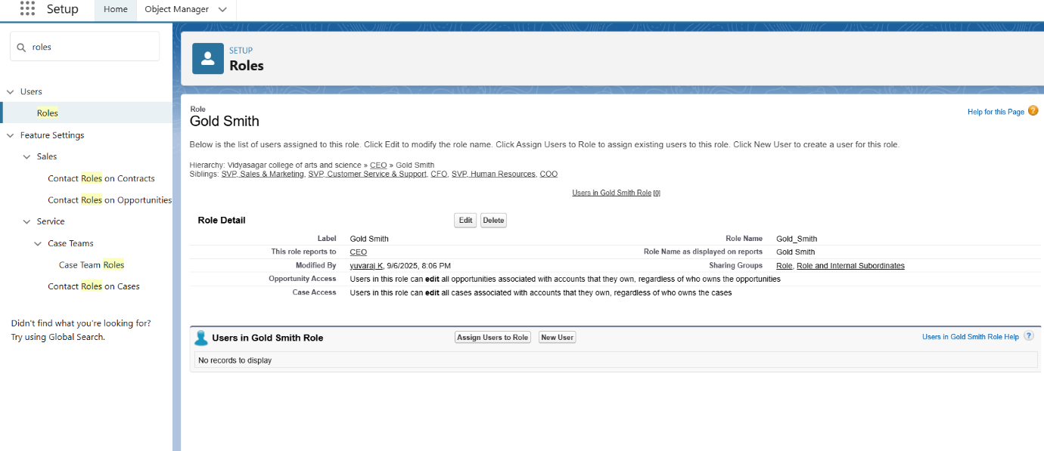

* **Create User**

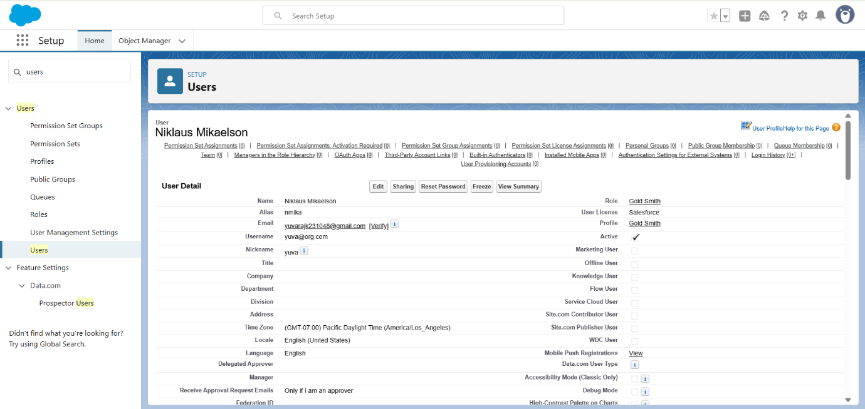

* **To Create a Gold Page layout**

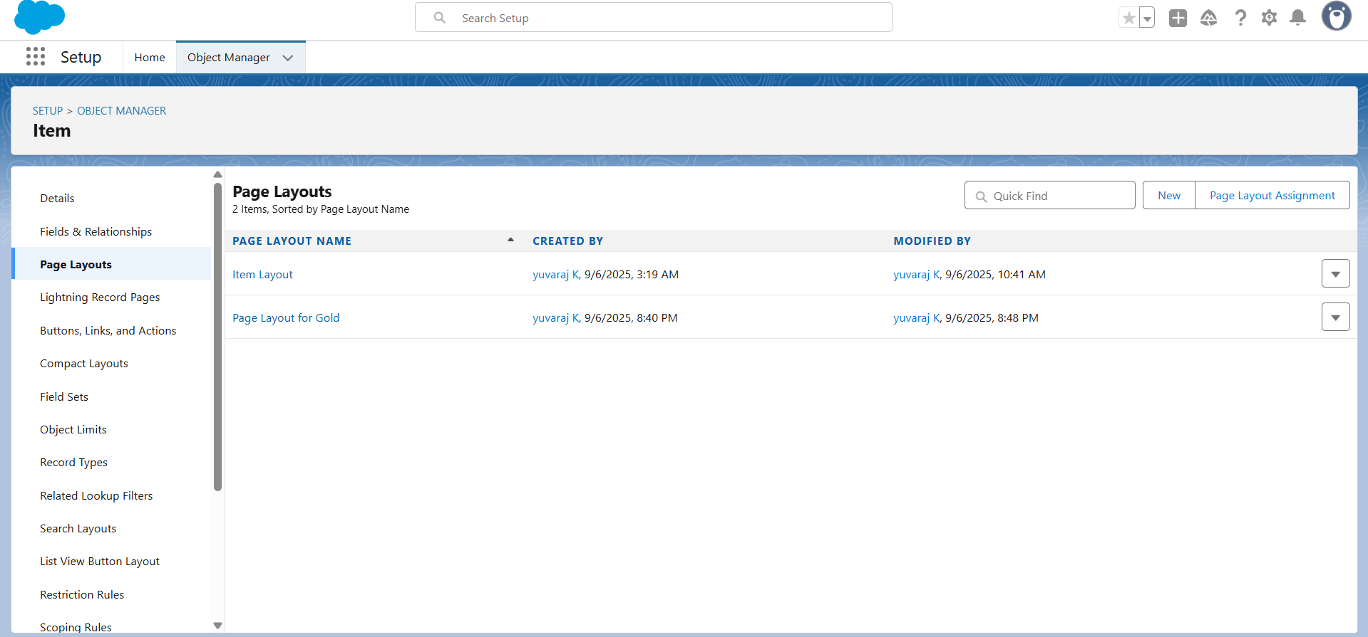

* **To Create a Silver Page layout**

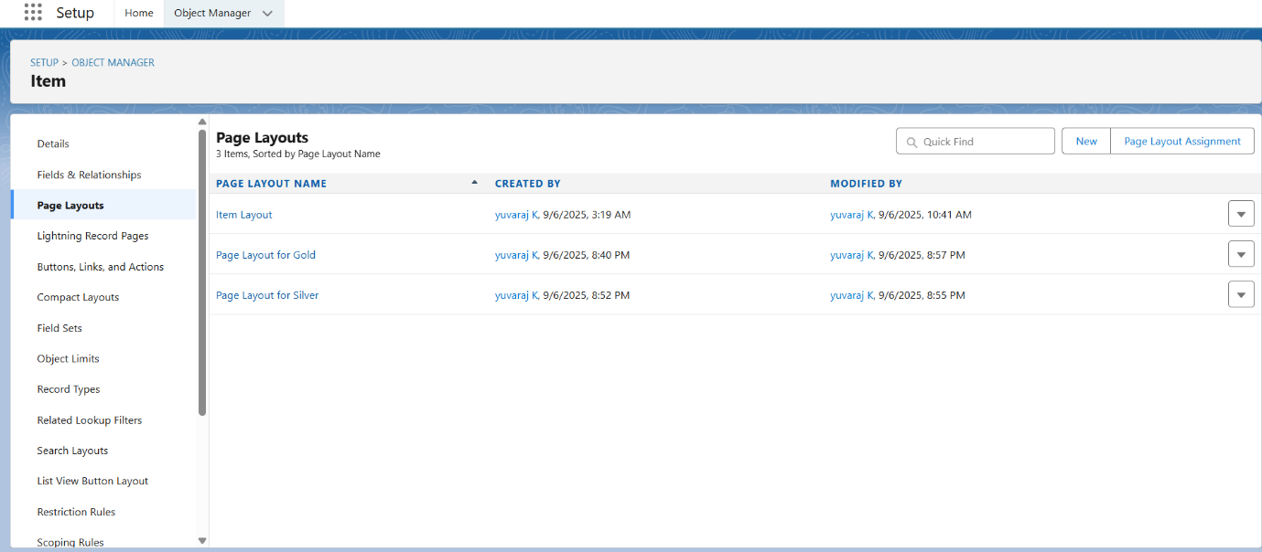

* 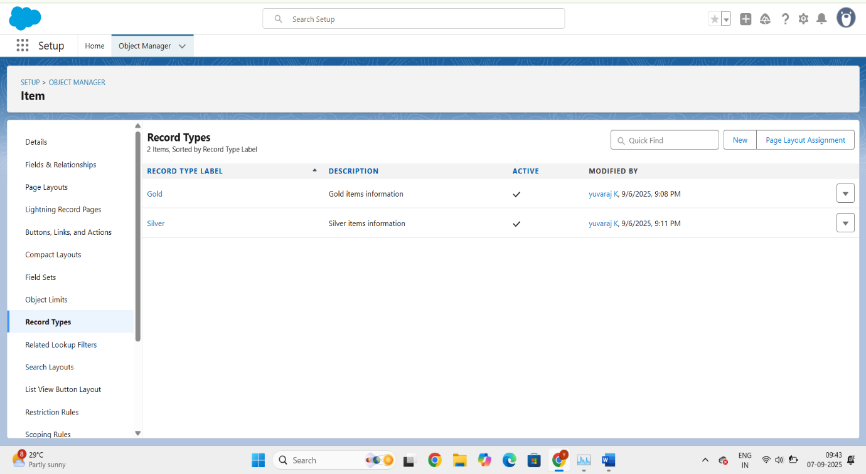**To create a Record Type**
* **Creating permission set**

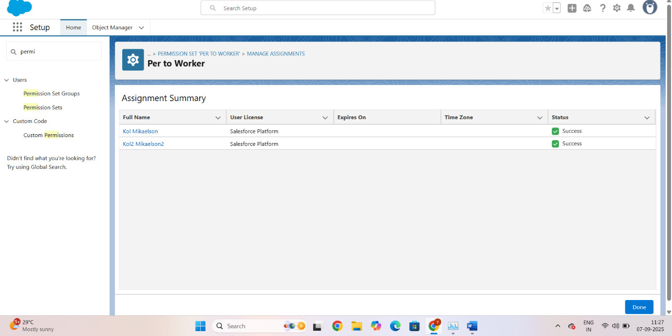

* **Create a Trigger Handler class**

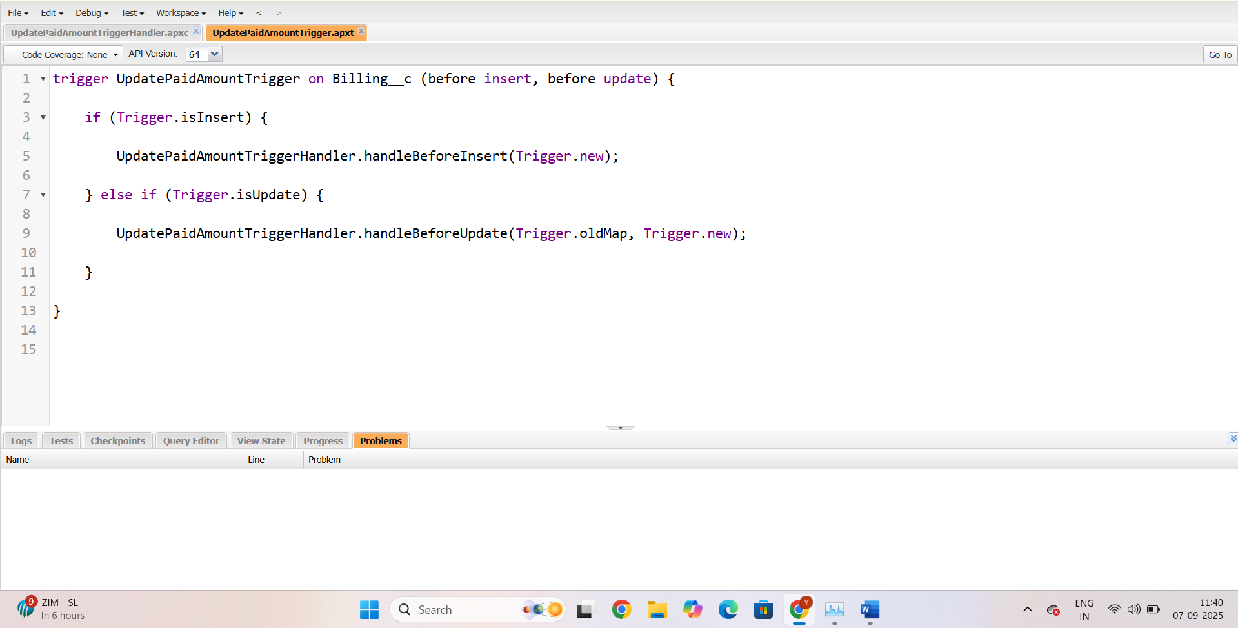

* 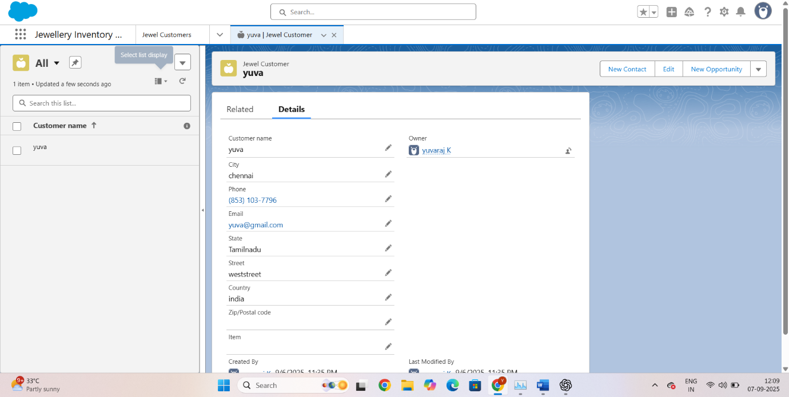**Create a Record (Jewel Customer)**

### **Create Report**

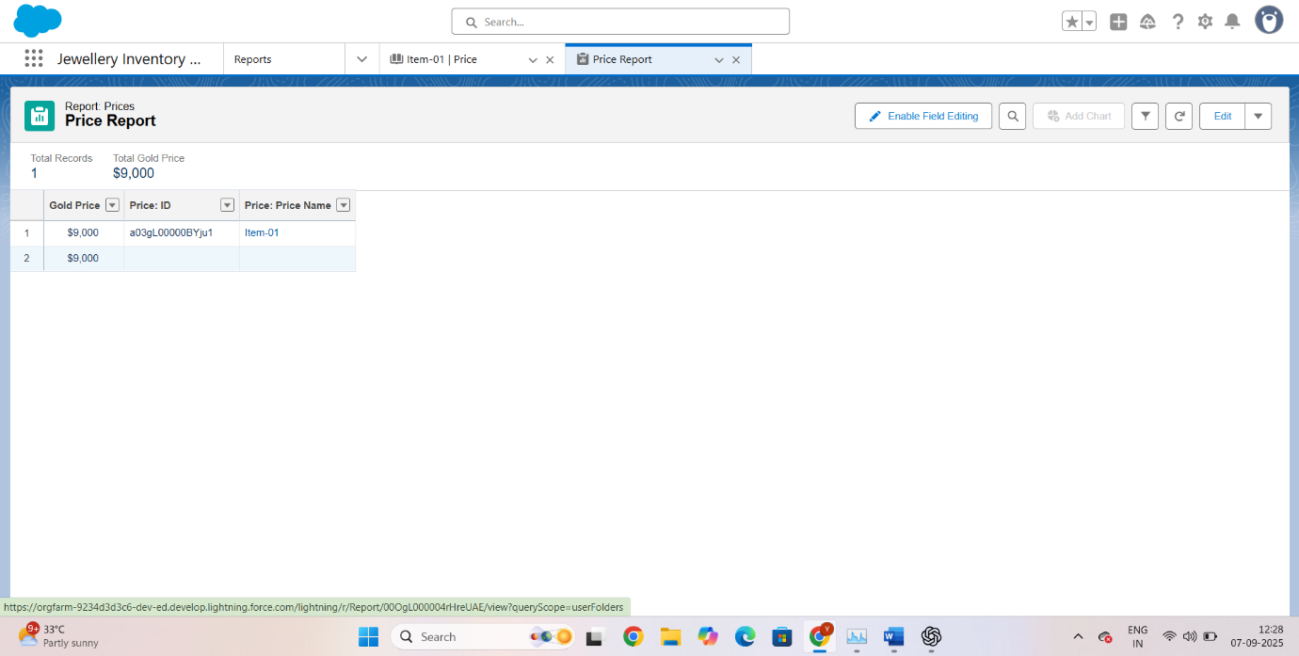

* **Create Dashboard**

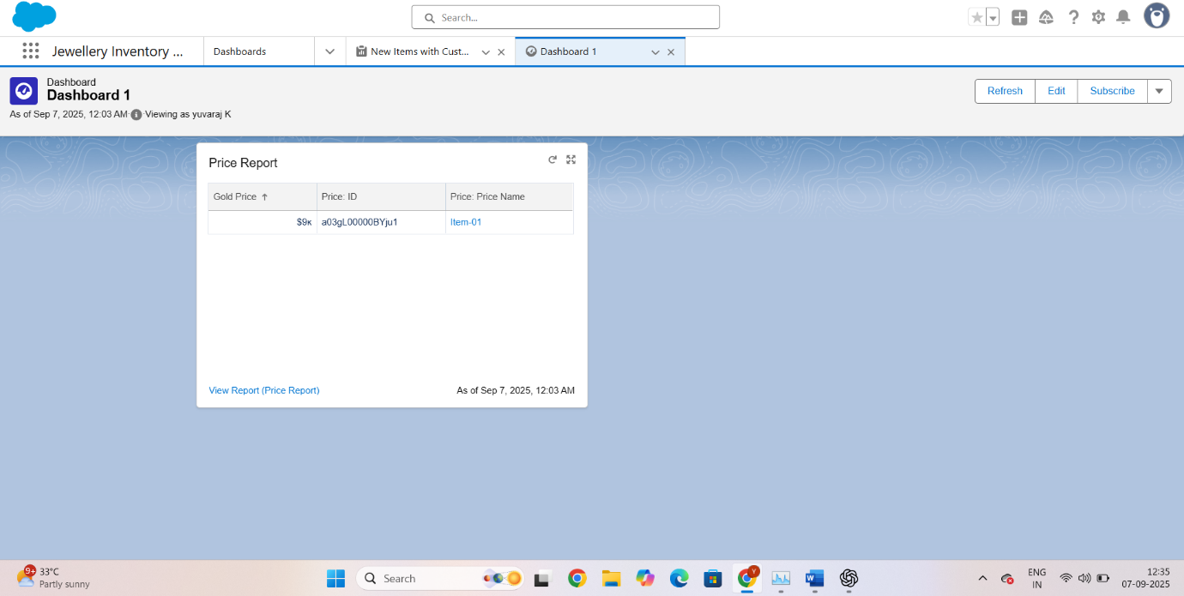

### **Create a Flow**

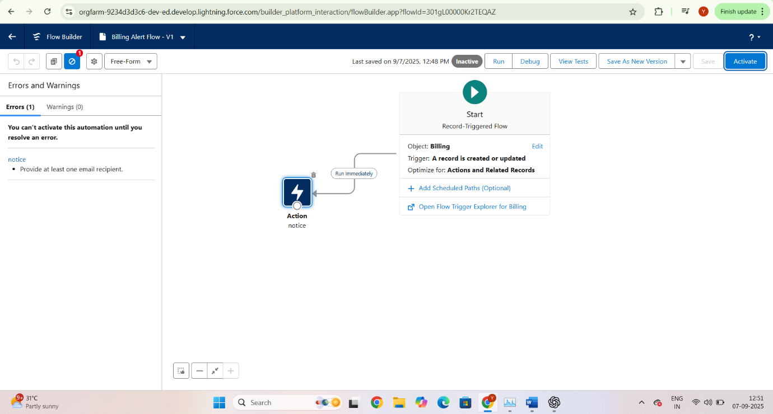

# **Advantages of Jewel CRM:**

1. Centralizes customer, sales, and inventory data in one system.
2. Improves customer satisfaction through loyalty programs and reminders.
3. Reduces manual errors in billing and stock management.
4. Provides real-time reports and dashboards for decision-making.
5. Supports repair and custom order tracking for better service delivery.

# **Disadvantages of Jewel CRM:**

1. Requires initial setup cost and staff training.
2. Customization can be complex and time-consuming.
3. Dependence on internet connectivity (for cloud systems).
4. Data migration from old records may be challenging.
5. Small businesses may find some features more advanced than necessary.

# **Conclusion:**

The Jewel CRM system provides a complete solution for managing jewellery business operations by combining customer management, sales, inventory, and service tracking in a single platform. It enhances efficiency, improves customer satisfaction, and supports business growth with accurate data and automation. Despite a few challenges like setup and training, the long-term benefits make Jewel CRM a valuable tool for modern jewellery businesses.

# **APPENDIX**

* Source Code: Provided in Apex Classes and Triggers

**Trigger Handler class :-**

public class UpdatePaidAmountTriggerHandler {

    public static void handleBeforeInsert(List<Billing__c> newBillings) {

        for (Billing__c billing : newBillings) {

            billing.Paid_Amount__c = billing.Paying_Amount__c;

        }

    }

    public static void handleBeforeUpdate(Map<Id, Billing__c> oldBillingsMap, List<Billing__c> updatedBillings) {

        for (Billing__c billing : updatedBillings) {

            Billing__c oldBilling = oldBillingsMap.get(billing.Id);

            Decimal oldPaidAmount = oldBilling.Paid_Amount__c;

            billing.Paid_Amount__c = oldPaidAmount + billing.Paying_Amount__c;

        }

    }

}

**Trigger :-**

trigger UpdatePaidAmountTrigger on Billing__c (before insert, before update) {

    if (Trigger.isInsert) {

        UpdatePaidAmountTriggerHandler.handleBeforeInsert(Trigger.new);

    } else if (Trigger.isUpdate) {

        UpdatePaidAmountTriggerHandler.handleBeforeUpdate(Trigger.oldMap, Trigger.new);

    }

}